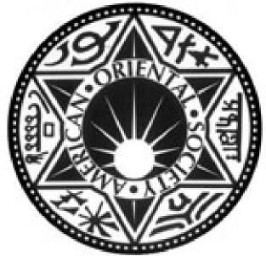

The "TLV" Pattern on Cosmic Mirrors of the Han Dynasty

Author(s): Schuyler Cammann

Reviewed work(s):

Source: *Journal of the American Oriental Society,* Vol. 68, No. 4 (Oct. - Dec., 1948), pp. 159- 167

Published by: American Oriental Society

Stable URL: <http://www.jstor.org/stable/595939>

Accessed: 11/05/2012 16:35

Your use of the JSTOR archive indicates your acceptance of the Terms & Conditions of Use, available at <http://www.jstor.org/page/info/about/policies/terms.jsp>

JSTOR is a not-for-profit service that helps scholars, researchers, and students discover, use, and build upon a wide range of content in a trusted digital archive. We use information technology and tools to increase productivity and facilitate new forms of scholarship. For more information about JSTOR, please contact [support@jstor.org](mailto:support@jstor.org).

|  |  |
| --- | --- |
|  | *American Oriental Society* is collaborating with JSTOR to digitize, preserve and extend access to *Journal of the American Oriental Society.* |

THE "TLV " PATTERN ON COSMIC MIRRORS OF THE HAN DYNASTY

SCHUYLER CAMMANN

UNIVERSITY OF PENNSYLVANIA

AMONG THE best-known of the Chinese bronze mirrors in our Occidental museums are the so-called " TLV " mirrors, most of which date from the Haan period (202 B. c.-220 A. D.) . The general type is quite common, and it has a number of sub­types differentiated by variations in background within the basic pattern.' The latter is character­ized by three sets of angles, resembling the letters T, L, and V. These marks have long puzzled the Western Orientalists, though the Chinese connois­seurs, since at least the twelfth century, have merely dismissed them as part of the general decoration on the mirrors included by " custom," and have not considered them as establishing a particular cate­gory of mirror.2 This later Chinese attitude ig­nores the fact that in Ancient China almost nothing was ever used for mere ornament, without some symbolic meaning. We shall see that the basic TLV pattern was apparently no exception to this general rule.

The pattern in question began in the Early Han period, about the second century B. C.' In its com­plete form it has a square frame around the central boss of the circular mirror, with T-shaped projec­tions from each side of the square. In addition, angles like inverted L's project inward from the outer circle below each T, and other angles re­sembling inverted V's jut from the same circle opposite each corner of the central square. (See fig. 1.) This basic pattern remained fairly con‑

For examples of the great diversity within the basic pattern, see B. Karlgren, " Huai and Han," *BMFEA,* XIII, 1941, pls. 57, 58 (F 21 and 23), 75 (K 1), 77

(K 9 and 10), 79 and 80. R. W. Swallow, *Ancient Chinese Bronze Mirrors* (Peiping, 1937) shows a num­ber of good examples, notably those in figs. 5 and 21. W. P. Yetts, *The Cull Chinese Bronzes* (London, 1939), 31, shows a particularly fine example of the Shang-fangs type.—For convenience we shall cite these three works hereafter merely by the authors' names.

2 See Swallow, 18; and note that in the *Po-ku eu-Pub,* the famous Sung catalogue published in 1107, some seventeen examples of TLV mirrors are illustrated, but have been given names based on their incidental decora­tion, or on a phrase from their inscriptions, with no slightest acknowledgment of any possible relationship in pattern.

3 See Karlgren, 15, 17, 18 ff. stant for about four centuries, although the details of the background varied considerably during that time. Sometimes, however, the T's were used alone ; other mirrors have only the T's and V's; 4 and eventually, both T's and L's dropped out, leaving only the central square and the V's, to make a basic pattern popular in the Later Six Dynasties and the Sui.° ( See fig. 3a, b, c.)—In short, the L's were apparently the least important element.

These marks which have given this class of mirror its popular name have still never been satisfactorily explained. A number of Western Orientalists, including Yetts in England, Karlbeck in Sweden, and Bishop White in Canada, have stated their belief that the marks were borrowed from the Han sun-dial to serve as ornamental de­tails and to symbolize whatever function they served on the dial.° This theory has been widely accepted, but it is not entirely convincing.

The sun-dial theory is based on the markings found on two Ancient Chinese sun-dials that have survived into modern times. The finest of these is now in Toronto, while the other was formerly in the Tuan Fang Collection.7 Both of these have a square enclosing the inner circle drawn around

4 For examples of mirrors with the T's alone, see the *Po-ku t`u-lu* 28. 13 and 18; for examples with only the T's and V's, see *Ibid.,* 28.15 and 35.

5 For later examples with only the V's, see Swallow, figs. 56, 548 and 603. Swallow was aware that these were related to the TLV mirrors (see his caption to fig. 56), but he failed to realize the significance of this relation­ship, which we shall consider below.

° See Yetts, 148-165; 0. Karlbeck, *Catalogue of the Collection of Chinese and Corean Bronzes at Hollwyl House* (Stockholm, 1938), 27-30; and White and Mill­man, " An Ancient Chinese Sun-dial," *Journal of the Royal Astronomical Society of Canada,* XXXII, 1938, 417-430.

7 The first dial was acquired by Bishop White for the Royal Ontario Museum of Archeology, in Toronto, and illustrations of it are shown in White and Millman, pl. 12 and fig 7, and in Yetts, fig. 40. The second dial was formerly in the Tuan Fang Collection but has since been lost; however ink-squeezes made from it show what the pattern was like—see White and Millman, fig. 1, or Yetts, fig. 39. A fragment of a third dial was also found, but not enough of it remained to show whether or not it had the TLV markings; see White and Millman, fig. 2.

the socket for the gnomon, with a T projecting from each side, L's opposite the T's, and V's in the corners. On the second example, they have ap­parently been scratched into a previously prepared dial as though by an afterthought,8 and this in itself would cause one to suspect that they were not necessary to the proper functioning of the dial. Various seemingly plausible reasons have been ad­vanced to account for these marks, and they sound almost convincing as regards the heads of the lower T and the lower inverted L; but the rest have had to be explained as having been placed there for symmetry, for lack of a better reason.8

In a traditional culture like that of Ancient China, the decoration on an object of ritual use is seldom derived from another object, but carries its own appropriate message, and the Chinese mirrors usually had ritual uses apart from their practical ones. If the TLV mirrors really did represent sun­dials, however, and if the similar markings on the two dials that have survived were essential to the instruments' use, how can one account for the fact that sometimes only the T's, and later only the V's appear on the mirrors ? These two sets of marks must have had individual meanings apart from their use as a group, and no explanation that fails to consider this can be wholly satisfactory.

Square boards displaying similarly placed L and

V markings, and sometimes the T's as well, are found on Han tomb reliefs and on some contem­porary bronzes." Many theories were proposed to explain them," including that of Sidney Kaplan who suggested that they were divination boards.12 —Even though Kaplan's theory has since been dis­proved along with the earlier ones, however, as we

8 See Yetts, 154, and White and Millman, 419.

9 Yetts makes some attempt to explain them all, but even lie has to resort to an appeal to symmetry to ex­plain some of them (162 and 163).

1° For illustrations of the boards on bas-reliefs, see White and Millman, fig. 3, and pl. 13b. For an example on a bronze mirror, see L. S. Yang, " A Note on the so-called TLV Mirrors and the Game *Liu-po," Harvard Journal of Asiatic Studies,* IX, 1945, pl. 1, facing 206.

11 The earlier theories have been reviewed by Yang, *Ibid.,* 202-203.

12 Sidney M. Kaplan, " On the Origin of the TLV Mirror," *Revue des Arts Asiatiques,* XI, 1937, 21-24. His conclusions were based on what was apparently an astrological dial, according to the deductions of Harada who found it at Lo-lang, and the illustrations of it reproduced by Kaplan do not suggest any remote con­nection with the boards in question. shall see in a moment, what seems to have been the real use of these boards probably did involve some concept of divination.

Dr. L. S. Yang of Harvard University finally resolved the long controversy over the identity and purpose of the boards by demonstrating conclu­sively that they were used for a game called *liu­poa.13* He went on to suggest, moreover, that the TLV pattern of the Han mirrors was borrowed from the game board—his reasoning for this being rather weak—and expressed the opinion that the design on the board might have been derived from that on the Han sun-dial." It seemed to him that the lines were probably utilized in playing the game, to indicate the position of the sticks or counters belonging to each player. But he was un­able to explain how, since by the sixth century A. D. the method of playing had been completely forgotten." It seems to us more likely, however, that while the lines on the board were very probably used in playing the game, they must have been conceived before the game as such was invented, the game being merely adapted to them ; and that the board represented something far more signifi­cant than the face of a sun-dial in itself.

The probable explanation of the form of the board can be reached through a study of the phi­losophy underlying Oriental games, all of which have a high cosmic content, unless this has been lost in recent times. In Mongolian chess, for ex­ample, the square board—with sixty-four white squares—is thought of either as the " square of Earth," or as a microcosmic unit of the whole, a patch of land, on which the forces of Good and Evil pit their strength in battle." While the board for Chinese chess, a quite different game, preserves traces of similar concepts, since it represents a strip of land on which opposing forces battle. In view of this enduring tradition, it would seem rather likely that the game of *liu-po* probably had this sort of symbolism too, with its board intended to represent the world, especially since the game appears to have begun sometime about the third

18 Yang, *Ibid.,* 202-206.

14 *Ibid.,* 203.

18 *Ibid.,* 204, 206. See note 25 below, for a suggestion regarding the principle of the game.

18 See S. Cammann, " Chess with Mongolian Lamas," *Natural History,* LV, 1946, 407-411, for a general dis­cussion of one form of this game. A more detailed article on both forms is still in preparation.

century B. C., from which period the books that have remained reveal an all-pervading preoccupa­tion with universe symbolism in every aspect of life.

Assuming for a moment that the *liu-po* board was intended to represent the Earth as it was then conceived, note that, like the sun-dial, the square board has no outer ring on it that would symbolize the encircling rim of the dome of heaven. On the sun-dial, a symbol of the sky would have been redundant from a logical point of view, because the sun was located in the sky above, and the dial was intended to mark the course of its passage over the Earth, according to the astronomic concepts of the time. But the mirror was a very different thing. As an object of ritual it was required to represent a complete symbol of the universe in microcosm, including the sky. And significantly, the circular outer rim of most of these mirrors has a continuous pattern of conventionalized clouds commonly known as the " drifting cloud " design.17

If this view is correct, and the pattern on the mirror was intended to represent the Universe, we shall still have to account for the presence of the angles on it. But before doing so, let us finish with the *liu-po* board. We mentioned its probable con­nection with divination in an earlier remark, be­cause every game of cosmic implication, such as this must have been, involves an element of fortune-telling. In a sense one's own fate is considered as being bound up in the game as the forces sym­bolized by the opposing pieces contend for mastery on the battleground of the world in miniature.—Incidentally, the Tibetans still play dice games *(liu-po* was apparently a dice game) in which one's destiny is supposed to be revealed in the course of the playing.18

" The earliest TLV mirrors were exceptions, having only a plain outer circle (see Swallow, fig. 11), and another type, the so-called *jih-kuange* mirrors, had a circular border composed of sixteen plain arcs enclosing the TLV portion (Swallow, fig. 12) ; while a third variety had only circles decorated with dog-tooth pat­terns, etc., as shown in Swallow, fig. 13. However all of these variations still formed a circular border enelosing the main pattern, and the circle as such was the symbol of heaven.

18 See Sarat Chandra Das, *Journey to Lhasa and Central Tibet,* edited by W. W. Rockhill, new ed. (New York, 1904), 338; and L. A. Waddell, *The Buddhism of Tibet,* 2nd ed. (Cambridge, 1939), 464-473. The latter describes several of the Tibetan games, without, however,

To return to the marks on the mirrors : the in­verted V's help to establish the whole inner pattern —as is obvious on some of the later mirrors, pre­viously alluded to, on which the T's and L's were left out. They serve to give the central portion of the mirror the appearance of a square placed in the middle of a cross, which forms a simple illustration of the Ancient Chinese concept of the Five Direc­tions—North, South, East and West, and Center —with additional connotations involving the Five Elements and the Four Seasons." (See fig. 3c.) In this diagram, the central square must represent China as the " Middle Kingdom," while the area around it, extending off into the four directions represents the " Four Seas."

The term " Four Seas " was purely figurative, and referred to the vast territories that stretched beyond the confines of China, inhabited by un­civilized barbarians, good and evil spirits, and wild animals 20 This concept gradually changed until the Four Seas were eventually thought of as actual water, especially after foreign contacts in the Tang introduced greater naturalism into Chinese art and thought. As a result, some of the rang mirrors, during the seventh and eighth centuries of our era portray the Five Directions of the Earth as a cross-shaped arrangement of mountains—four ranges radiating from a central peak which forms the mirror's boss—with conventionalized waves filling the angles and sweeping around the points of the ranges.2' However, the symbolic diagram of the Earth as a cross-shaped pattern of rectangular forms continued on even into rang times (See

**fig.** 3d).22

Thus, the chief function of the V's was ap‑

sufficiently emphasizing that they are used as games as well as for more serious divination on particular occasions.

19 See the *Shih mingd,* a Han work *(Szii-pu teung-Van* ed.), p. 2, for contemporary ideas on the interrelation­ship of the directions, seasons, and elements.

20 The *Erb, yae,* China's oldest existing lexicon, ex­plains that the (lands of) the Eastern Barbarians, Northern Barbarians, Western Barbarians, and Southern Barbarians were known as the " Four Seas." See also M. Granet, *La Penske Chinoise* (Paris, 1934), 358 ff.

21 See S. Cammann, " A Rare 'Pang Mirror," *The* Art *Quarterly,* IX (Detroit) 1946, 95-96, and fig. 1.

22 See Sir Aurel Stein, *Serindia* (Oxford, 1921), pl. 103, for a Buddhist diagram of the Earth in cross-form, presumably of Pang date. This particular diagram will be discussed more fully in the text, below.

parently to mark off the boundaries of the four quarters of the world ; while the spaces within the V's merely represented the non-existence of land. The essential separation of the latter from the rest of the pattern is evident. For even when all the available reserves in the pattern are filled with scroll designs or mere curlicues, the space within the V's is almost always left severely plain.23 Note that the outer circle cuts across the corners so that the spaces within the V's cannot form complete rectangles as they did on the *liu-po* boards, because old tradition conceived of the circle of heaven as falling within the bounds of the square of earth." For that same reason the outer ends of the " Four Seas " are rounded instead of being square, as they would be if shown at their full length. In short, the total plan of the mirror gives the impression that someone had placed a circular *pib,* the jade emblem of heaven, on top of a square plan of the Earth, like the *liu-po* board,25 and then cut off the projecting corners of the latter, flush with the curve of the *pi.* (See fig. 3f.)

23 The only exceptions are on some of the earliest examples which have vine tendrils or conventionalized dragons writhing freely among the angle lines, the cosmic features being less emphasized than on the later more naturalistic mirrors; or on the latest type, of the Sui period, which frequently have monster heads to relieve the bareness within the V's. See Tomioka Benzo, *koky5 no kenkytif,* pl. 25, figs. 1 and 2.

24 For the ancient Chinese concept that the circle derives from within the square, see the *Chou-pi suan­chingg (Szii-pu ts`ung-k`an* ed.) 2b, 18, *et* passim.

The common explanation that the pattern on these mirrors represents " the square of earth within the circle of heaven " is quite impossible. For it is not consistent with Ancient Chinese philosophy, which thought of the circle of heaven as inscribed within the square of earth. If this pattern does represent the uni­verse consisting of both heaven and earth, as we are trying to show, then the outer circle must indeed repre­sent heaven; in which case not only is everything en­closed within it to be considered as Earth, but the Earth must be further understood as extending out beyond it. (See also Granet, 335.)

25 But not the *liu-po* board itself, as this apparently did not have a circle within the central square. In fact, we believe that the goal of the game *liu-po* must have been to get one or more of one's circular counters into the center of the board, to establish an axis for symbolic control of the Universe. This is entirely in accord with the philosophy behind the Chinese universe-in-microcosm concept, as we shall see below, in considering some of the sentiments expressed in the inscriptions on these mirrors.

As further proof that the pattern of the square in a cross specifically represents the Earth, we sug­gest that one refer to the paintings on the ceilings of the Tun-huang caves, notably cave VIII.26 There the canopy of the sky also portrays the con­cept of the Five Directions, since Heaven and Earth were thought to have complementary fea­tures." But instead of an inner square around a circle (the mirror boss), we have an inner circle around another circle ; 28 and instead of angular segments cut from the corners, the canopy has cir­cular ones. (See fig. 3e.) This is apparently be­cause of the old Chinese tradition that the symbols of heaven must be circular, and the symbols of earth must be square (or angular). Thus the sym­bol of the Five Directions of Heaven logically consisted of a circle in a rounded cross, while the symbol of the Five Directions of Earth consisted of a square in an angular cross.

The central square of the mirror, which we have seen represented China, has a very prominent boss representing the center of the 'Universe. In con­formance with Han traditions, this could have been considered literally, as representing some specific location, such as the World Mountain *(K'un-lun Shan),* or more likely the Imperial Palace, or the *Ming rangd—a* traditional temple hall of great cosmic significance.29 We shall see, however, that in terms of Han philosophy, the boss could have been considered more philosophically as the center of the Universe in a more abstract sense, represent­ing any point around which the various elements and forces that constituted the Universe were in harmonious balance.

From the boss, considered as the symbolic cen­ter of the World, rays which may have represented auspicious emanations are shown as extending out in four directions on an X-axis—Northwest to Southeast, and Northeast to Southwest—indicated by stylized forms like arrowheads ; while some‑

2' See Pelliot, *Les Grottes de Touen-Houang,* I, pl. 28. 27 See the *Ho-t`u kua-ti hsiangh* (in the *Shuo fu,* ch. 5), p. 1; and also Granet, 352-353.

22 This central circle in the canopy of the sky on the Tun-huang ceilings is analogous to the *ocudus* in a Western dome, but it is not therefore derived from the latter. We shall consider this topic in a later article on the subject of Chinese cosmology.

29 The significance of the *Ming rang* has been bril­liantly expounded by Granet, see particularly 102 ff., 178 ff., and 318 ff.

times, smaller arrows point out in the intermediate directions. The broad band which outlines this inner square has the four T's projecting from it in the four cardinal directions. These orientations are indicated by the fact that when the twelve cyclical characters are placed in the bordering band on Later Han mirrors,3° the characters which stand for North, South, East and West fall opposite the T's.

The explanation for these T's is provided by the traditional concept of the Four Gates of the Middle Kingdom, mentioned in Chinese classical litera­ture.31 This idea was also reflected in the four gates to the *Ming rang,* the four inner gates of the Han place of sacrifice, and those of the im­perial tombs 32—all of which were apparently built as representations of the Universe in microcosm, which is what we would expect in view of the similar practices in other traditional cultures.

The probable reason why the men of Han chose a T-shaped symbol to represent a gate, as well as the appropriateness of this symbol, is indicated by the small model of a stone gateway at the Art Institute in Chicago, dating from the third cen­tury A. n., which probably reflects the Han style of architecture, though it was made about seventy years after the fall of the Later Han.33 Its most notable feature appears to be the prominent ma­sonry wings topped with tiles on either side of a rather narrow opening, accounting for the relative breadth of the heads of the T's on the mirrors in comparison with the rather narrow " road " lead­ing back into the inner square.

The T-symbol to indicate a gate survived into Tang times (618-907) as part of the decoration on the Buddhist mandala drawings, which also repre‑

8° See Swallow fig. 5, or Yetts, pl. 31.

31 For some specific references to the Four Gates in Chinese literature, see the *Pien-tzk lei-pieni* 92, 17-17b.

33 The four gates of the *Ming rang,* symbolically shutting out the four groups of barbarians, are men­tioned in the *Li chi (Shih-san-ching thing-wen* ed.), 62. The *I li* speaks of four gates to the palace enclosure in which the Son of Heaven received his lords during the Chou *(Ibid.,* same ed., 44). The Later Han place of sacrifice had two enclosures, an inner and outer one, with four gates in each *(Hou Han shu 17.* 3) ; while the contemporary imperial tombs had four *sm.-I-ma)* gates, apparently corresponding to the four gates of the same name in the imperial palace of that period *(Ibid.* 16. 7b, commentary).

33 See the *Handbook of the Department of Oriental Art,* Art Institute of Chicago, 1933, fig. 15. sented the universe in microcosm. On the sketches for mandalas found by Sir Aurel Stein at Tun­huang, the Earth was usually drawn as a square, having a T-shaped element at each side, with the name or color of the appropriate direction.34 An­other of these drawings is somewhat different, but very significant. It is drawn in cross-form, being composed of an inner square with four outer squares, but the gates are now at the ends of the latter (see fig. 3d) .35 This was probably the result of changing ideas regarding the nature of the Universe, due to widened conceptions of geography, for in the Pang, China was no longer an isolated " Middle Kingdom " but was open to influences from abroad. At any rate, it explains why we no longer find the T's at the sides of the inner square on the later mirrors. In fact their complete ab­sence is probably explained by the fact that the gates were doubtless considered as beyond the rim of the sky, as indicated by the more common type of mandala drawing from Tun-huang.—Probably as a survival from these diagrams of the rang period, the Lama Buddhist mandalas still have prominent T's on the four sides of the square of Earth, and their true nature is usually further emphasized by actual archways portrayed over each T. (See fig. 2.)36

The inverted L's at the ends of the " Four Seas " on the Han mirrors would appear to be more diffi­cult to explain. But they, too, seem to have repre­sented barriers, perhaps analogous to the gates of the outer enclosure at the Han place of sacrifice. What they were considered as shutting off, would seem to be indicated by some interesting features

34 See *Serindia,* 975, Ch. 00190.

35 *Ibid.* pl. 103, Ch. 00186, already referred to in note 22 above.

36 The four gates on the sides of the square of Earth on these Lama mandalas traditionally have on their tops the eight-spoked Wheel of the Law, which was originally a solar wheel, and still is associated with the sun in Mongolia. This suggests that the T-shaped gates on the Han mirrors might have had solar connotations, and the suggestion seems corroborated by another cir­cumstance. When the cyclical characters are used on the border of the inner square, those for the morning hours fall behind the T on the East, where the sun rises; those for midday fall behind the T on the South (which was the top of the mirror to the Chinese) ; those for afternoon and evening fall behind the T on the West, where the sun sets; and those for the night hours fall behind the T on the North, where the sun was believed to pass behind the northern corner of the World before rising again on the following day .

on one of the most elaborate examples of the TLV type, a large mirror with a *Shang-fang* inscription, dating from the first century A. D., which we acquired in Kansu.37 This shows a small water bird hiding under the inverted L's in the Eastern and Southern quadrants, the regions subject to the warm, dry influences of the *Yang* element; while the same bird is shown emerging from under the L in the Western sector, where the moist *Yin,* influ­ence begins; and is shown high above the L, with head upraised, in the Northern quadrant which is under the full influence of the *Yin,.* The bird in question seems to be the yue, a form of snipe (some­times confused with the kingfisher), which was considered in the Han as a weatherbird." It was said to come out to herald the aproach of rainy weather. The fact that this bird was traditionally associated with dampness, and that in the regions notably dry it stays behind the inverted L's, would suggest that the area back of the L's must have been intended to represent damp places. This fits in with the traditional Han cosmology which pic­tured great marshes and swamps at the ends of the Earth, beyond the " Four Seas." 39

The fact that the boundary lines are bent, yet not completely closed like a box but left open on one side, has several possible explanations. In the first place, the Han Chinese apparently did not conceive of precise boundaries outside of China, to compare with those that set off the Middle King­dom from the barbarous rest of the world : even the " Four Seas " were not entirely set off from each other but had linking territory in common, and there was no absolute cleavage between them and the great marshes beyond. Secondly, an opening was no doubt left to symbolize the gateway by which the reviving rains and the winds of the four directions came into the central portions of the Earth from its outer boundaries. Moreover, even today, the outer gates of walled cities in the older parts of China admit one at an angle—usually

" This has certain close resemblances to the Cull mirror (Yetts, pl. 31) but has certain original features of its own.—Incidentally, Yetts has pointed out that not all of these *Shang-fang* mirrors were necessarily made in the Shang-fang imperial workshops (Yetts, 120) .

38 See the *Pu-shu chi-ch'eng, ch'in-ch'ung tienk* 46. 4.

*" Huai-nan Tzill* 4. 3b describes these swamps by name. A few literary references to the Four Swamps *(ssii tsem)* are quoted in the *Pien-teit lei-pien* 92. 17-17b. explained by the statement that evil spirits travel in straight lines, and thus cannot enter. The fact that the L's probably represented barriers seems further supported by the fact that they disappeared entirely at the time when the T-gates of the inner square were considered as being transferred to the extremities of the Universe, when they would have naturally displaced any previously existing entrances.

Thus, the function of the L's seems to have been to indicate the gates or partial barriers that set off the swamps at the ends of the Earth. Moreover, since all bend in the same direction around the mirror, they serve to give the pattern as a whole a rotating effect, and perhaps they had the added function of representing the rotation of the four seasons, which were closely associated with the four directions. Also, further investigation may disclose some definite significance in the crescent-shaped figures behind the L's on some mirrors (shown in two forms behind the Northern and Southern L's in figure 1). These may turn out to represent lunar symbolism.

One of the Later Han forms of the TLV mirror (the *jih kuang* type) has fine lines extending from the ends of the central square to, or through, the V's, and from the middle of the T's through the feet of the L's.4° These divide the mirror into nine parts, the central square and eight peripheral seg­ments, probably with the deliberate intention of recalling the traditional nine regions of the Earth *(Chiu Chour).41* China, too, was traditionally thought of as having nine divisions (similarly named)," and that concept is indirectly indicated —probably also intentionally—by the small bosses or " nipples " between each pair of cyclical char­acters, when the latter are represented, on the border of the inner square." If one draws two

48 Swallow, fig. 12, shows a rubbing of one of these.

41 See the *Shih chi* 74. 2b for a discussion (in the life of Mencius) of the concept of China having nine provinces, and the Earth having nine regions, including China. This concept was so deeply implanted in Chinese thought that it continued on in the literature long after China had many more than nine provinces and after it was known that the world outside had more than nine divisions. From the beginning it was apparently based on the concept of the nine directions rather than any political fact.

42 *Ibid.*

43 On later mirrors of the Sui and rang periods, the cyclical characters were replaced by symbolic animals.

lines connecting the opposite bosses across the square horizontally, and two more connecting the opposte bosses vertically, one achieves the familiar " pattern of the tortoise shell " with the nine rectangular divisions.

As for the eight, slightly larger " nipples " usu­ally placed two in each quadrant opposite the ends of the T's outside the inner square, they probably represented the Eight Pillars, mountains that tra­ditionally supported the canopy of heaven." Simi­larly, on the smaller mirrors, when four " nipples " are shown opposite the four corners of the square, they probably represent the related concept of the four pillars of heaven.

These nipples or bosses, like the T's, V's, and especially the L's, very probably had still other astrological and cosmological meanings for the men of the Han, beyond those we have suggested. But it is enough for our present purpose if we have demonstrated that all of these conventionalizations rightfully belonged on the portion that stood for the Earth, in the mirror's symbolic representation of the Universe in microcosm.

Let us consider for a moment the various beings that were shown with these TLV patterns as occu­pants of the four quadrants representing the " Four Seas." The simpler mirrors usually have only eight of them, either eight animals, or eight birds —generally quail. Four of the former are the well-known four creatures of the Four Directions, known to the Chinese as the Four Spirits *ssil sheng :* the Azure Dragon of the East, the Red Bird of the South, the White Tiger of the West, and the Black Tortoise (and snake) of the North. The other four animals seem to change slightly from one mirror to another, but with the previous four, they may have been intended to represent a group of eight unspecified spirits, called the *pa shenh,* mentioned in Han texts.45 The eight quail may stand for the Eight Winds of Chinese tradition, but more likely they are a symbol of spiritual meta­morphosis, much desired by the Taoists. For it was believed that a quail was a lowly frog who had suc‑

See Cammann, " Rare rang Mirror," 99-100, for a dis­cussion of the various implications of the cyclical signs, which had the same significance whether shown in the form of characters or pictorially, as animals.

44 See Granet, 343 ff., and the *Pien-tzii lei-pien* 103. 5b.

45 See the *Shih chi* 28 (part 1). 9, for two allusions to these. ceeded in changing himself into a bird, thereby liberating his spirit to soar aloft."

On the larger *Shang-fang* mirrors, we find the eight animals, a number of quail (usually eight), and sometimes representations of the *yii* bird which we have discussed above in connection with the L's. In addition, we find four or five semi-human crea­tures, recognizable from mirrors of other types—notably the Hsi-wang-mu series—as conventionali­zations of spirits or immortals who were believed to roam the Four Seas (see below). We can also make out assorted mountain goats, an occasional bear, and various birds other than those already mentioned, all of which could have represented either specific spirits or merely the game in the " hunting preserve " outside the borders of China.47 In short, previous attempts to explain some of them as symbols of constellations seem quite out of place. Not only were all these creatures terrestial ones, but most if not all had some valid association with the Four Seas on which they were depicted.

The only celestial elements in the inner pattern of the mirror that represents that portion of the Earth under the dome of heaven, are the sun and moon," which were thought to pursue their courses between heaven and earth. In other words, the patterns on the TLV mirrors, regardless of their complexity, apparently depicted the Universe as though seen by a Heavenly eye looking down from the palace of the Supreme Emperor through the hole in the dome of the sky."

Lastly, there is the matter of the inscriptions around the inner circle within the raised rim of the more elaborate types of TLV mirrors. A con­siderable number of these, including most if not all of the typical ones, have already been expertly analyzed by Karlgren,5° so further work on them would seem unnecessary. However, a few of the

46 See A. Forke's translation of the *Lun Hengn,* part I, p. 326. This says in part; " Frogs become quails and sparrows turn into clams. Man longing for bodily trans­formation would like to resemble quails and crabs . . . without a metamorphose of the body, life cannot be lengthened."

41 See Granet, 358-360.

4S See Yetts, 139-140, for a discussion of these sun and moon symbols.

'° For the fundamental, Ancient Chinese concept of the dome of the sky with its aperture leading into Heaven, see Granet, 353 ff.

50 See B. Karlgren, " Early Chinese Mirror Inscrip­tions," *BMFEA,* VI (1934), 9-74.

sentiments frequently expressed in these inscrip­tions deserve a brief review, as they have particular relevance to our subject, and help to explain why the Universe pattern was used.

The first of these sentiments, commonly found on the *Shang-fang* mirrors, may be translated as follows :

On the mirror are immortals who do not know old age. When they are thirsty they drink from the Jade Springs, When they are hungry they eat dates;

They wander over China and roam the Four Seas."

This not only indicates two purposes of the mir­ror, to convey wishes for long life to a recipient, or to express hopes of future life as an immortal for a person in whose tomb it was placed; but in ad­dition, the reference to China and the Four Seas as the realm of the immortals would seem to con­firm our impression that that is exactly what these TLV mirrors were intended to portray.

The second sentiment which helps to indicate why a Universe pattern was shown on these mirrors is expressed rather cryptically by the phrases, " Azure Dragon on the left, White Tiger on the right, Red Bird in front, and Black Warrior (tor­toise and snake) behind." 52 In other words, the owner of the mirror is pictured figuratively as being at the center of the Universe, with the Four Directions symbolized by the Four Spirits on the four sides of him.

These phrases may derive from a certain passage found in the *Li chi,* though both may reflect a popular concept of the Han period, or earlier (if this portion of the *Li chi* actually dates from the Chou as Karlgren has suggested).53 The passage in question says, " When (the army) is marching, it has in front the Red Bird, and at the rear the Black Warrior, to the left the Azure Dragon, and to the right the White Tiger, with the *Chao-yaoi* (a star in the Big Dipper) overhead, strengthen‑

51 For this inscription, see *Ibid.,* 65 (no. 215). Karl­gren has translated this somewhat differently, to say, " They roam about in the whole world and ramble [everywhere between] the four seas." However, the ex­pression *Tien hsiao* at that time was still used by the literati to mean China, and the term " Four Seas," as we have seen, was commonly considered to refer to four lands, and not necessarily to four bodies of water. If the expression " between the four seas " had been intended, the writer of the inscription could have altered the wording to express it; but the present wording cer­tainly does not justify interpolating the word " between."

52 *Ibid.,* 26. See also the *Po-ku t`u-/u* 23. 9

57 Karlgren, *Ibid.* ing its power." " Later Chinese and foreign com­mentators have concluded that this passage must refer to the symbols on the banners carried by the army.55 They are probably right as far as they go; but why were such banners carried, and why did the animals of the Four Directions and the Northern star provide strength and confidence ? Simply because, by the tenets of Han philosophy as expressed by Huai-nan Tzti and others, when an army (or an individual) was situated at the center of the Earth, on the Universal axis between the Earth and the apex of the sky in the North­ern heavens, that position provided metaphysical strength. Just why it should provide strength and confidence we shall discuss more fully in a moment.

Another related sentiment, expressed in several variations, says, " May your sons and grandsons occupy (or "rule," or "control ") the center." 56 This last thought has been rather materialistically interpreted as meaning, " May your descendants be Ministers or high officials in the Central Govern­ment, or the Imperial Capital." 57 However, such an interpretation is necessarily incomplete, for it disregards the fact that to the men of Han, all these expressions regarding occupying or ruling the center had other, more metaphysical meanings which were undoubtedly much more significant to them, considering the intellectual climate of that period.

In the first place, people of that time believed that fortunate immortals ruled over palaces on K`un-lun Shan at the center of the World where they enjoyed eternal bliss." Secondly, it was

54 *Li chi (Shih-san-thing ching-wen* ed.) 4-5. The last phrase as translated above, " strengthening its [the army's] power," comes from the *Tei-hai* Dictionary, fourth definition under the character nur. This inter­pretation is also justified by what is known of the Han and pre-Han philosophy as expressed in more detail in the text above! The translation of the last phrase as " all to stimulate their fury," as Karlgren has rendered it, completely distorts the spirit of the passage.

55 See Karlgren, *Ibid.,* 26.

56 See *Ibid.,* 30-31 for variations. On 31, Karlgren, discussing the phrase " Eight sons and nine grandsons govern the center," says, " To translate here `eight sons and nine grandsons govern the centre of *the mirror'* is clearly impossible." Literally speaking, it is impossible, because the intention of the inscription is apparently to say, " may they govern the center of the Universe, as symbolized on the mirror."

57 See *Ibid.,* 31.

58 *See* the *Shen i chingo (Han-Wei ts`ung-shu* ed.), 13­13b. Even though the Han ascription of this work is

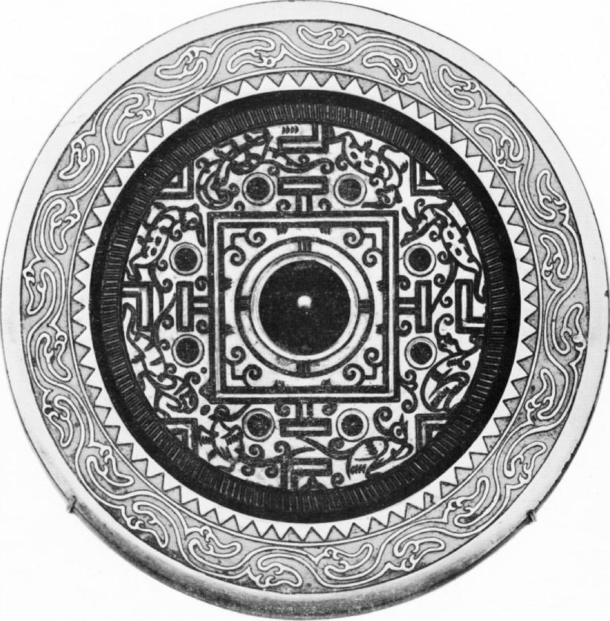

FIG. 1. A Representative TIN Mirror. Freer Gallery, Washington, D. C.

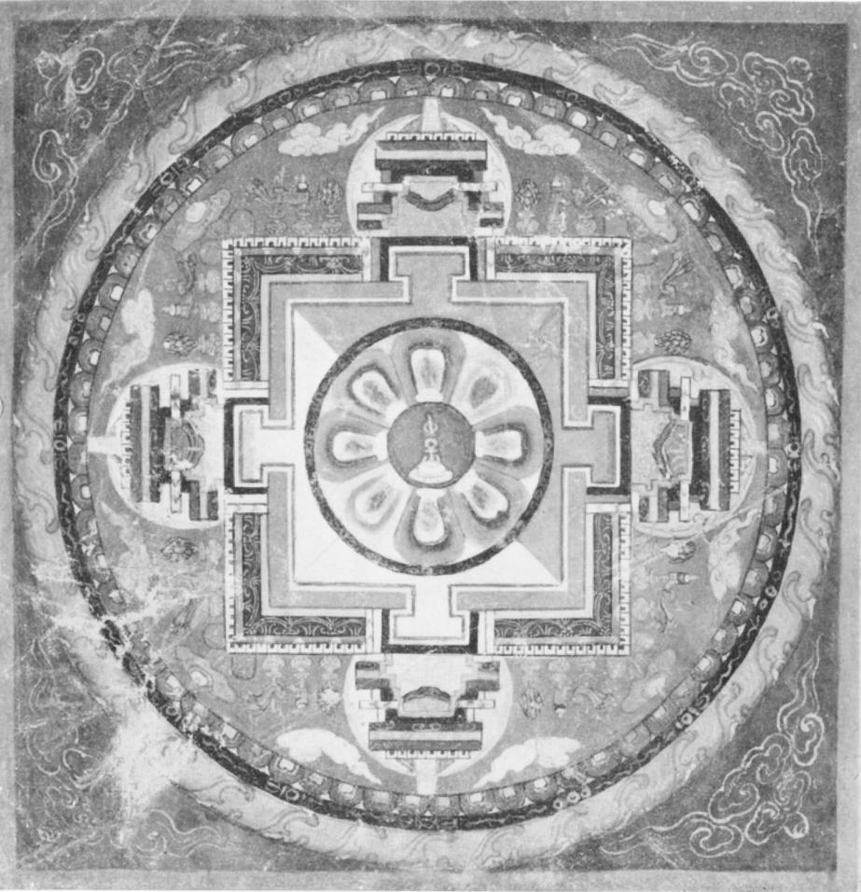

FIG. 2. A Simple Form of Lama Manchla. Author's Collection.

d. rang diagram e. Pattern on T'am;. f. Pattern made by placil:g

a. T's alone.

b. Only T's & V's.

|  |  |  |  |
| --- | --- | --- | --- |
|  |  |  |  |
| PS |
|  |

of Earth. Canopy of Heaven. circular pi on square

Earth-diagram.

FIG. 3. Some Basic Patterns.*

" NOTE : these are merely skeleton sketches to show the elemental patterns as simply as possible. For actual mirrors with the,pattern shown in a, b and c, see refs. in notes 4 and 5. For the complete diagram of the rang mandala (d), see ref. in note 22; and for the original painting of the canopy of heaven on the Tun-huang ceiling (e), see ref. in note 26.

thought that if one could live in harmony with all the elements in one's private universe—thereby being figuratively situated at its axis—one could not only control it, but could have power over the greater Universe as well." This could signify the possession of magical Taoist powers, such as were believed to accrue from the building of a *Ming Tang;* 60 or it could mean more simply that a person who occupied the center of his own universe, possessing complete adjustment to it (or—to use a modern term for a very old concept—personal inte­gration), would automatically possess the natural strength and self-confidence that came with that harmony.

Thus, the wish that an individual, or his descen­dants, might occupy the center, undoubtedly re­ferred at least in part to the center of the Universe as depicted on the mirrors; and it could signify—in addition to possible connotations of future offi­cial position in the center of the land (and hence

most doubtful, it appears to express ideas that had survived from the period, at least in part. We have par­tially translated the section relating to *.11`un-lun shan* in the Coomaraswamy Memorial Volume, *Art and Thought* (London, 1947), 127.

59 Another form of inscription seems to have this concept in mind when it says, " the barbarians of the four directions have submitted "—to the Emperor of China, implied. (See Karlgren, " Huai and Han," 113, description of L2). As the Emperor of China was the ruler of the " Middle Kingdom," the deeper implication of the world)—either hope of Immortality, hope  
for possession of occult powers, or merely hope for  
the enjoyment of harmony with Nature or the *Tao.*

In concluding our brief survey of the TLV problem, it should be emphasized that there is still no absolute proof that the basic pattern on these mirrors was taken from the markings added to the sun-dial, or from those on the *liu-po* board, or from the lay-out of the *Ming Tang,* the Imperial Palace, or a tomb. It seems probable that no one of these was necessarily derived from any one of the others. All of them must have drawn their patterns from a common source; yet that need not have been a concrete thing. It could well have been merely a common conception of the nature of the Universe, from which men conceived various simple, ordered diagrams to symbolize the great idea of Universal harmony. And through these diagrams, such as the pattern on the mirrors, an individual could come to feel that he occupied the center of the greater Universe, under the direct influence of Heaven.

is apparently that greater power had accrued to the center of the Universe.

" Some of the mirror inscriptions do refer specifically to the building of a *Ming rang* (see " Huai and Han," 114, description of L5). This sentiment probably does not refer exclusively to an architectural event, however, but is doubtless an allusion to the establishment of a cosmic focal point by the Emperor, who (even though in this case he was a usurper ) was considered as the paramount ruler of the Center, and Master of the *Tao.*

GLOSSARY OF CHINESE TERMS

|  |  |  |
| --- | --- | --- |
|  |  |  |

**TEXT**

|  |  |  |
| --- | --- | --- |
| 1. "it 2. th.g |  | 1. A |

**NOTES**